Q1.

MongoDB Enterprise atlas-jsun6x-shard-0:PRIMARY> db.addresses.find()

{ "_id" : ObjectId("60788344875ef61d244746df"), "address" : { "building" : "1007", "coord" : [ -73.856077, 40.848447 ], "street" : "Morris Park Ave", "zipcode" : "10462" }, "borough" : "Bronx", "cuisine" : "Bakery", "grades" : [ { "date" : ISODate("2014-03-03T00:00:00Z"), "grade" : "A", "score" : 2 }, { "date" : ISODate("2013-09-11T00:00:00Z"), "grade" : "A", "score" : 6 }, { "date" : ISODate("2013-01-24T00:00:00Z"), "grade" : "A", "score" : 10 }, { "date" : ISODate("2011-11-23T00:00:00Z"), "grade" : "A", "score" : 9 }, { "date" : ISODate("2011-03-10T00:00:00Z"), "grade" : "B", "score" : 14 } ], "name" : "Morris Park Bake Shop", "restaurant_id" : "30075445" }

…….

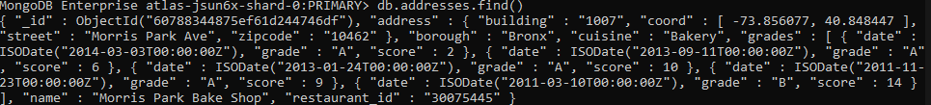

Q2.

MongoDB Enterprise atlas-jsun6x-shard-0:PRIMARY> db.addresses.find({},{"restaurant_id" : 1,"name":1,"borough":1,"cuisine" :1});

{ "_id" : ObjectId("60788344875ef61d244746df"), "borough" : "Bronx", "cuisine" : "Bakery", "name" : "Morris Park Bake Shop", "restaurant_id" : "30075445" }

{ "_id" : ObjectId("60788344875ef61d244746e0"), "borough" : "Brooklyn", "cuisine" : "Hamburgers", "name" : "Wendy'S", "restaurant_id" : "30112340" }

{ "_id" : ObjectId("60788344875ef61d244746e1"), "borough" : "Manhattan", "cuisine" : "Irish", "name" : "Dj Reynolds Pub And Restaurant", "restaurant_id" : "30191841" }

{ "_id" : ObjectId("60788344875ef61d244746e2"), "borough" : "Brooklyn", "cuisine" : "American ", "name" : "Riviera Caterer", "restaurant_id" : "40356018" }

{ "_id" : ObjectId("60788344875ef61d244746e3"), "borough" : "Queens", "cuisine" : "Jewish/Kosher", "name" : "Tov Kosher Kitchen", "restaurant_id" : "40356068" }

{ "_id" : ObjectId("60788344875ef61d244746e4"), "borough" : "Queens", "cuisine" : "American ", "name" : "Brunos On The Boulevard", "restaurant_id" : "40356151" }

{ "_id" : ObjectId("60788344875ef61d244746e5"), "borough" : "Staten Island", "cuisine" : "Jewish/Kosher", "name" : "Kosher Island", "restaurant_id" : "40356442" }

{ "_id" : ObjectId("60788344875ef61d244746e6"), "borough" : "Brooklyn", "cuisine" : "Delicatessen", "name" : "Wilken'S Fine Food", "restaurant_id" : "40356483" }

{ "_id" : ObjectId("60788344875ef61d244746e7"), "borough" : "Brooklyn", "cuisine" : "American ", "name" : "Regina Caterers", "restaurant_id" : "40356649" }

{ "_id" : ObjectId("60788344875ef61d244746e8"), "borough" : "Brooklyn", "cuisine" : "Ice Cream, Gelato, Yogurt, Ices", "name" : "Taste The Tropics Ice Cream", "restaurant_id" : "40356731" }

{ "_id" : ObjectId("60788344875ef61d244746e9"), "borough" : "Bronx", "cuisine" : "American ", "name" : "Wild Asia", "restaurant_id" : "40357217" }

{ "_id" : ObjectId("60788344875ef61d244746ea"), "borough" : "Brooklyn", "cuisine" : "American ", "name" : "C & C Catering Service", "restaurant_id" : "40357437" }

{ "_id" : ObjectId("60788344875ef61d244746eb"), "borough" : "Brooklyn", "cuisine" : "Chinese", "name" : "May May Kitchen", "restaurant_id" : "40358429" }

{ "_id" : ObjectId("60788344875ef61d244746ec"), "borough" : "Manhattan", "cuisine" : "American ", "name" : "1 East 66Th Street Kitchen", "restaurant_id" : "40359480" }

{ "_id" : ObjectId("60788344875ef61d244746ed"), "borough" : "Brooklyn", "cuisine" : "Jewish/Kosher", "name" : "Seuda Foods", "restaurant_id" : "40360045" }

{ "_id" : ObjectId("60788344875ef61d244746ee"), "borough" : "Brooklyn", "cuisine" : "Ice Cream, Gelato, Yogurt, Ices", "name" : "Carvel Ice Cream", "restaurant_id" : "40360076" }

{ "_id" : ObjectId("60788344875ef61d244746ef"), "borough" : "Queens", "cuisine" : "Ice Cream, Gelato, Yogurt, Ices", "name" : "Carvel Ice Cream", "restaurant_id" : "40361322" }

{ "_id" : ObjectId("60788344875ef61d244746f0"), "borough" : "Brooklyn", "cuisine" : "Delicatessen", "name" : "Nordic Delicacies", "restaurant_id" : "40361390" }

{ "_id" : ObjectId("60788344875ef61d244746f1"), "borough" : "Manhattan", "cuisine" : "American ", "name" : "Glorious Food", "restaurant_id" : "40361521" }

{ "_id" : ObjectId("60788344875ef61d244746f2"), "borough" : "Brooklyn", "cuisine" : "American ", "name" : "The Movable Feast", "restaurant_id" : "40361606" }

Type "it" for more

MongoDB Enterprise atlas-jsun6x-shard-0:PRIMARY>

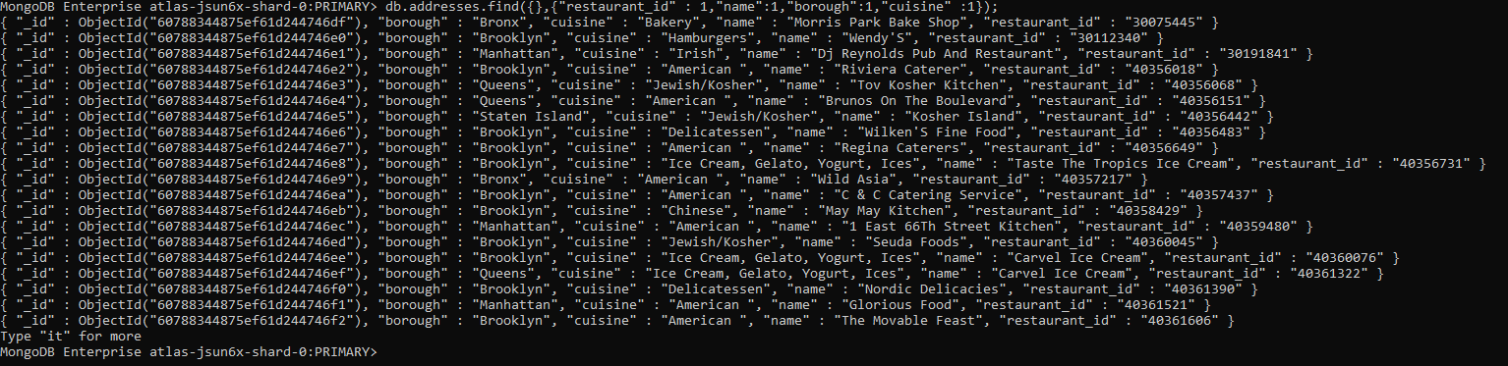

Q3.

MongoDB Enterprise atlas-jsun6x-shard-0:PRIMARY> db.addresses.find({},{"restaurant_id" : 1,"name":1,"borough":1,"cuisine" :1,"_id":0});

{ "borough" : "Bronx", "cuisine" : "Bakery", "name" : "Morris Park Bake Shop", "restaurant_id" : "30075445" }

{ "borough" : "Brooklyn", "cuisine" : "Hamburgers", "name" : "Wendy'S", "restaurant_id" : "30112340" }

{ "borough" : "Manhattan", "cuisine" : "Irish", "name" : "Dj Reynolds Pub And Restaurant", "restaurant_id" : "30191841" }

{ "borough" : "Brooklyn", "cuisine" : "American ", "name" : "Riviera Caterer", "restaurant_id" : "40356018" }

{ "borough" : "Queens", "cuisine" : "Jewish/Kosher", "name" : "Tov Kosher Kitchen", "restaurant_id" : "40356068" }

{ "borough" : "Queens", "cuisine" : "American ", "name" : "Brunos On The Boulevard", "restaurant_id" : "40356151" }

{ "borough" : "Staten Island", "cuisine" : "Jewish/Kosher", "name" : "Kosher Island", "restaurant_id" : "40356442" }

{ "borough" : "Brooklyn", "cuisine" : "Delicatessen", "name" : "Wilken'S Fine Food", "restaurant_id" : "40356483" }

{ "borough" : "Brooklyn", "cuisine" : "American ", "name" : "Regina Caterers", "restaurant_id" : "40356649" }

{ "borough" : "Brooklyn", "cuisine" : "Ice Cream, Gelato, Yogurt, Ices", "name" : "Taste The Tropics Ice Cream", "restaurant_id" : "40356731" }

{ "borough" : "Bronx", "cuisine" : "American ", "name" : "Wild Asia", "restaurant_id" : "40357217" }

{ "borough" : "Brooklyn", "cuisine" : "American ", "name" : "C & C Catering Service", "restaurant_id" : "40357437" }

{ "borough" : "Brooklyn", "cuisine" : "Chinese", "name" : "May May Kitchen", "restaurant_id" : "40358429" }

{ "borough" : "Manhattan", "cuisine" : "American ", "name" : "1 East 66Th Street Kitchen", "restaurant_id" : "40359480" }

{ "borough" : "Brooklyn", "cuisine" : "Jewish/Kosher", "name" : "Seuda Foods", "restaurant_id" : "40360045" }

{ "borough" : "Brooklyn", "cuisine" : "Ice Cream, Gelato, Yogurt, Ices", "name" : "Carvel Ice Cream", "restaurant_id" : "40360076" }

{ "borough" : "Queens", "cuisine" : "Ice Cream, Gelato, Yogurt, Ices", "name" : "Carvel Ice Cream", "restaurant_id" : "40361322" }

{ "borough" : "Brooklyn", "cuisine" : "Delicatessen", "name" : "Nordic Delicacies", "restaurant_id" : "40361390" }

{ "borough" : "Manhattan", "cuisine" : "American ", "name" : "Glorious Food", "restaurant_id" : "40361521" }

{ "borough" : "Brooklyn", "cuisine" : "American ", "name" : "The Movable Feast", "restaurant_id" : "40361606" }

Type "it" for more

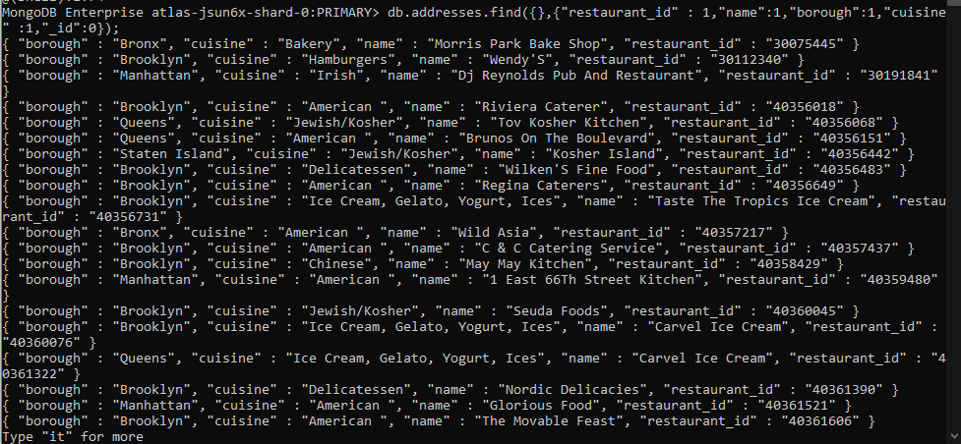

Q4.

MongoDB Enterprise atlas-jsun6x-shard-0:PRIMARY> db.addresses.find({},{"restaurant_id" : 1,"name":1,"borough":1,"address.zipcode" :1,"_id":0});

{ "address" : { "zipcode" : "10462" }, "borough" : "Bronx", "name" : "Morris Park Bake Shop", "restaurant_id" : "30075445" }

{ "address" : { "zipcode" : "11225" }, "borough" : "Brooklyn", "name" : "Wendy'S", "restaurant_id" : "30112340" }

{ "address" : { "zipcode" : "10019" }, "borough" : "Manhattan", "name" : "Dj Reynolds Pub And Restaurant", "restaurant_id" : "30191841" }

{ "address" : { "zipcode" : "11224" }, "borough" : "Brooklyn", "name" : "Riviera Caterer", "restaurant_id" : "40356018" }

{ "address" : { "zipcode" : "11374" }, "borough" : "Queens", "name" : "Tov Kosher Kitchen", "restaurant_id" : "40356068" }

{ "address" : { "zipcode" : "11369" }, "borough" : "Queens", "name" : "Brunos On The Boulevard", "restaurant_id" : "40356151" }

{ "address" : { "zipcode" : "10314" }, "borough" : "Staten Island", "name" : "Kosher Island", "restaurant_id" : "40356442" }

{ "address" : { "zipcode" : "11234" }, "borough" : "Brooklyn", "name" : "Wilken'S Fine Food", "restaurant_id" : "40356483" }

{ "address" : { "zipcode" : "11219" }, "borough" : "Brooklyn", "name" : "Regina Caterers", "restaurant_id" : "40356649" }

{ "address" : { "zipcode" : "11226" }, "borough" : "Brooklyn", "name" : "Taste The Tropics Ice Cream", "restaurant_id" : "40356731" }

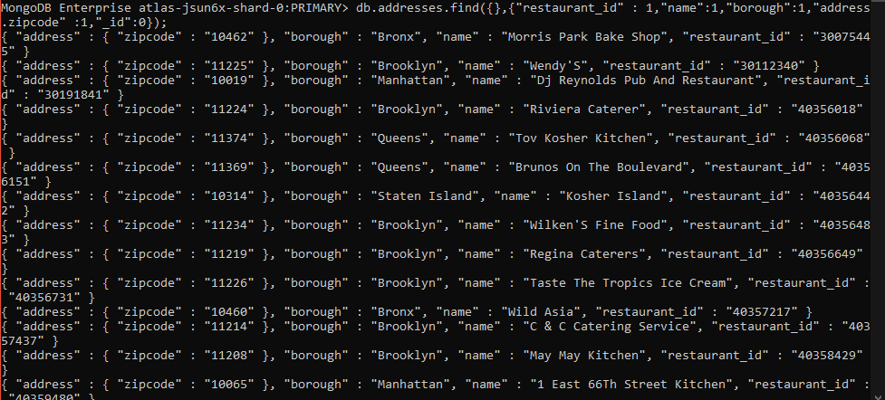

Q5.

MongoDB Enterprise atlas-jsun6x-shard-0:PRIMARY> db.addresses.find({"borough": "Bronx"}).limit(5);

{ "_id" : ObjectId("60788344875ef61d244746df"), "address" : { "building" : "1007", "coord" : [ -73.856077, 40.848447 ], "street" : "Morris Park Ave", "zipcode" : "10462" }, "borough" : "Bronx", "cuisine" : "Bakery", "grades" : [ { "date" : ISODate("2014-03-03T00:00:00Z"), "grade" : "A", "score" : 2 }, { "date" : ISODate("2013-09-11T00:00:00Z"), "grade" : "A", "score" : 6 }, { "date" : ISODate("2013-01-24T00:00:00Z"), "grade" : "A", "score" : 10 }, { "date" : ISODate("2011-11-23T00:00:00Z"), "grade" : "A", "score" : 9 }, { "date" : ISODate("2011-03-10T00:00:00Z"), "grade" : "B", "score" : 14 } ], "name" : "Morris Park Bake Shop", "restaurant_id" : "30075445" }

{ "_id" : ObjectId("60788344875ef61d244746e9"), "address" : { "building" : "2300", "coord" : [ -73.8786113, 40.8502883 ], "street" : "Southern Boulevard", "zipcode" : "10460" }, "borough" : "Bronx", "cuisine" : "American ", "grades" : [ { "date" : ISODate("2014-05-28T00:00:00Z"), "grade" : "A", "score" : 11 }, { "date" : ISODate("2013-06-19T00:00:00Z"), "grade" : "A", "score" : 4 }, { "date" : ISODate("2012-06-15T00:00:00Z"), "grade" : "A", "score" : 3 } ], "name" : "Wild Asia", "restaurant_id" : "40357217" }

..

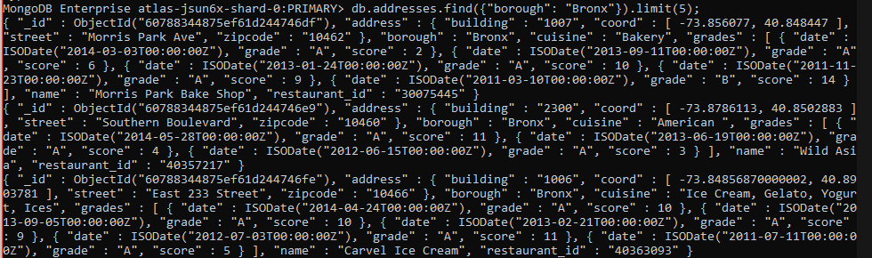

Q6.

MongoDB Enterprise atlas-jsun6x-shard-0:PRIMARY> db.addresses.find({"borough": "Bronx"}).limit(5);

{ "_id" : ObjectId("60788344875ef61d244746df"), "address" : { "building" : "1007", "coord" : [ -73.856077, 40.848447 ], "street" : "Morris Park Ave", "zipcode" : "10462" }, "borough" : "Bronx", "cuisine" : "Bakery", "grades" : [ { "date" : ISODate("2014-03-03T00:00:00Z"), "grade" : "A", "score" : 2 }, { "date" : ISODate("2013-09-11T00:00:00Z"), "grade" : "A", "score" : 6 }, { "date" : ISODate("2013-01-24T00:00:00Z"), "grade" : "A", "score" : 10 }, { "date" : ISODate("2011-11-23T00:00:00Z"), "grade" : "A", "score" : 9 }, { "date" : ISODate("2011-03-10T00:00:00Z"), "grade" : "B", "score" : 14 } ], "name" : "Morris Park Bake Shop", "restaurant_id" : "30075445" }

{ "_id" : ObjectId("60788344875ef61d244746e9"), "address" : { "building" : "2300", "coord" : [ -73.8786113, 40.8502883 ], "street" : "Southern Boulevard", "zipcode" : "10460" }, "borough" : "Bronx", "cuisine" : "American ", "grades" : [ { "date" : ISODate("2014-05-28T00:00:00Z"), "grade" : "A", "score" : 11 }, { "date" : ISODate("2013-06-19T00:00:00Z"), "grade" : "A", "score" : 4 }, { "date" : ISODate("2012-06-15T00:00:00Z"), "grade" : "A", "score" : 3 } ], "name" : "Wild Asia", "restaurant_id" : "40357217" }

{ "_id" : ObjectId("60788344875ef61d244746fe"), "address" : { "building" : "1006", "coord" : [ -73.84856870000002, 40.8903781 ], "street" : "East 233 Street", "zipcode" : "10466" }, "borough" : "Bronx", "cuisine" : "Ice Cream, Gelato, Yogurt, Ices", "grades" : [ { "date" : ISODate("2014-04-24T00:00:00Z"), "grade" : "A", "score" : 10 }, { "date" : ISODate("2013-09-05T00:00:00Z"), "grade" : "A", "score" : 10 }, { "date" : ISODate("2013-02-21T00:00:00Z"), "grade" : "A", "score" : 9 }, { "date" : ISODate("2012-07-03T00:00:00Z"), "grade" : "A", "score" : 11 }, { "date" : ISODate("2011-07-11T00:00:00Z"), "grade" : "A", "score" : 5 } ], "name" : "Carvel Ice Cream", "restaurant_id" : "40363093" }

{ "_id" : ObjectId("60788344875ef61d24474702"), "address" : { "building" : "1236", "coord" : [ -73.8893654, 40.81376179999999 ], "street" : "238 Spofford Ave", "zipcode" : "10474" }, "borough" : "Bronx", "cuisine" : "Chinese", "grades" : [ { "date" : ISODate("2013-12-30T00:00:00Z"), "grade" : "A", "score" : 8 }, { "date" : ISODate("2013-01-08T00:00:00Z"), "grade" : "A", "score" : 10 }, { "date" : ISODate("2012-06-12T00:00:00Z"), "grade" : "B", "score" : 15 } ], "name" : "Happy Garden", "restaurant_id" : "40363289" }

{ "_id" : ObjectId("60788344875ef61d24474714"), "address" : { "building" : "277", "coord" : [ -73.8941893, 40.8634684 ], "street" : "East Kingsbridge Road", "zipcode" : "10458" }, "borough" : "Bronx", "cuisine" : "Chinese", "grades" : [ { "date" : ISODate("2014-03-03T00:00:00Z"), "grade" : "A", "score" : 10 }, { "date" : ISODate("2013-09-26T00:00:00Z"), "grade" : "A", "score" : 10 }, { "date" : ISODate("2013-03-19T00:00:00Z"), "grade" : "A", "score" : 10 }, { "date" : ISODate("2012-08-29T00:00:00Z"), "grade" : "A", "score" : 11 }, { "date" : ISODate("2011-08-17T00:00:00Z"), "grade" : "A", "score" : 13 } ], "name" : "Happy Garden", "restaurant_id" : "40364296" }

MongoDB Enterprise atlas-jsun6x-shard-0:PRIMARY>

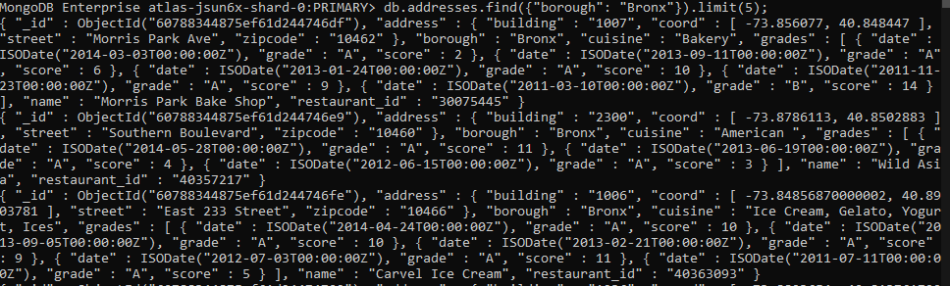

Q7.

MongoDB Enterprise atlas-jsun6x-shard-0:PRIMARY> db.addresses.find({"borough": "Bronx"}).limit(5);

{ "_id" : ObjectId("60788344875ef61d244746df"), "address" : { "building" : "1007", "coord" : [ -73.856077, 40.848447 ], "street" : "Morris Park Ave", "zipcode" : "10462" }, "borough" : "Bronx", "cuisine" : "Bakery", "grades" : [ { "date" : ISODate("2014-03-03T00:00:00Z"), "grade" : "A", "score" : 2 }, { "date" : ISODate("2013-09-11T00:00:00Z"), "grade" : "A", "score" : 6 }, { "date" : ISODate("2013-01-24T00:00:00Z"), "grade" : "A", "score" : 10 }, { "date" : ISODate("2011-11-23T00:00:00Z"), "grade" : "A", "score" : 9 }, { "date" : ISODate("2011-03-10T00:00:00Z"), "grade" : "B", "score" : 14 } ], "name" : "Morris Park Bake Shop", "restaurant_id" : "30075445" }

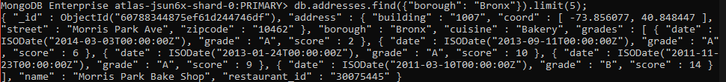

Q8. MongoDB Enterprise atlas-jsun6x-shard-0:PRIMARY> db.addresses.find({grades : { $elemMatch:{"score":{$gt : 90}}}});

{ "_id" : ObjectId("60788344875ef61d2447483d"), "address" : { "building" : "65", "coord" : [ -73.9782725, 40.7624022 ], "street" : "West 54 Street", "zipcode" : "10019" }, "borough" : "Manhattan", "cuisine" : "American ", "grades" : [ { "date" : ISODate("2014-08-22T00:00:00Z"), "grade" : "A", "score" : 11 }, { "date" : ISODate("2014-03-28T00:00:00Z"), "grade" : "C", "score" : 131 }, { "date" : ISODate("2013-09-25T00:00:00Z"), "grade" : "A", "score" : 11 }, { "date" : ISODate("2013-04-08T00:00:00Z"), "grade" : "B", "score" : 25 }, { "date" : ISODate("2012-10-15T00:00:00Z"), "grade" : "A", "score" : 11 }, { "date" : ISODate("2011-10-19T00:00:00Z"), "grade" : "A", "score" : 13 } ], "name" : "Murals On 54/Randolphs'S", "restaurant_id" : "40372466" }

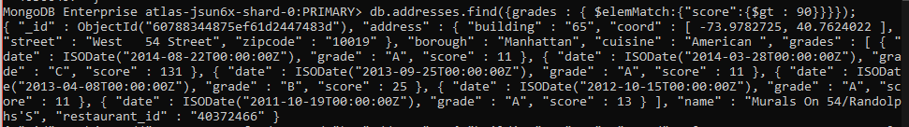

Q9.

MongoDB Enterprise atlas-jsun6x-shard-0:PRIMARY> db.addresses.find({grades : { $elemMatch:{"score":{$gt : 80 , $lt :100}}}});

{ "_id" : ObjectId("60788344875ef61d244748de"), "address" : { "building" : "345", "coord" : [ -73.9864626, 40.7266739 ], "street" : "East 6 Street", "zipcode" : "10003" }, "borough" : "Manhattan", "cuisine" : "Indian", "grades" : [ { "date" : ISODate("2014-09-15T00:00:00Z"), "grade" : "A", "score" : 5 }, { "date" : ISODate("2014-01-14T00:00:00Z"), "grade" : "A", "score" : 8 }, { "date" : ISODate("2013-05-30T00:00:00Z"), "grade" : "A", "score" : 12 }, { "date" : ISODate("2013-04-24T00:00:00Z"), "grade" : "P", "score" : 2 }, { "date" : ISODate("2012-10-01T00:00:00Z"), "grade" : "A", "score" : 9 }, { "date" : ISODate("2012-04-06T00:00:00Z"), "grade" : "C", "score" : 92 }, { "date" : ISODate("2011-11-03T00:00:00Z"), "grade" : "C", "score" : 41 } ], "name" : "Gandhi", "restaurant_id" : "40381295" }

{ "_id" : ObjectId("60788344875ef61d24474a41"), "address" : { "building" : "130", "coord" : [ -73.984758, 40.7457939 ], "street" : "Madison Avenue", "zipcode" : "10016" }, "borough" : "Manhattan", "cuisine" : "Pizza/Italian", "grades" : [ { "date" : ISODate("2014-12-24T00:00:00Z"), "grade" : "Z", "score" : 31 }, { "date" : ISODate("2014-06-17T00:00:00Z"), "grade" : "C", "score" : 98 }, { "date" : ISODate("2013-12-12T00:00:00Z"), "grade" : "C", "score" : 32 }, { "date" : ISODate("2013-05-22T00:00:00Z"), "grade" : "B", "score" : 21 }, { "date" : ISODate("2012-05-02T00:00:00Z"), "grade" : "A", "score" : 11 } ], "name" : "Bella Napoli", "restaurant_id" : "40393488" }

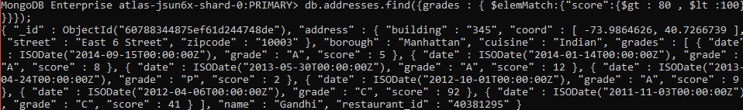

Q10.

MongoDB Enterprise atlas-jsun6x-shard-0:PRIMARY> db.addresses.find({"address.coord" : {$lt : -95.754168}});

{ "_id" : ObjectId("60788345875ef61d24474d27"), "address" : { "building" : "3707", "coord" : [ -101.8945214, 33.5197474 ], "street" : "82 Street", "zipcode" : "11372" }, "borough" : "Queens", "cuisine" : "American ", "grades" : [ { "date" : ISODate("2014-06-04T00:00:00Z"), "grade" : "A", "score" : 12 }, { "date" : ISODate("2013-11-07T00:00:00Z"), "grade" : "B", "score" : 19 }, { "date" : ISODate("2013-05-17T00:00:00Z"), "grade" : "A", "score" : 11 }, { "date" : ISODate("2012-08-29T00:00:00Z"), "grade" : "A", "score" : 11 }, { "date" : ISODate("2012-04-03T00:00:00Z"), "grade" : "A", "score" : 12 }, { "date" : ISODate("2011-11-16T00:00:00Z"), "grade" : "A", "score" : 7 } ], "name" : "Burger King", "restaurant_id" : "40534067" }

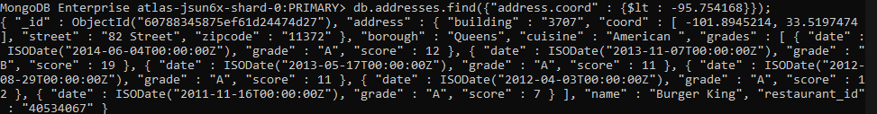

Q11.

MongoDB Enterprise atlas-jsun6x-shard-0:PRIMARY> db.addresses.find({$and:[{"cuisine" : {$ne :"American "}}, {"grades.score" : {$gt : 70}},{"address.coord" : {$lt : -65.754168}}]})

{ "_id" : ObjectId("60788344875ef61d244748de"), "address" : { "building" : "345", "coord" : [ -73.9864626, 40.7266739 ], "street" : "East 6 Street", "zipcode" : "10003" }, "borough" : "Manhattan", "cuisine" : "Indian", "grades" : [ { "date" : ISODate("2014-09-15T00:00:00Z"), "grade" : "A", "score" : 5 }, { "date" : ISODate("2014-01-14T00:00:00Z"), "grade" : "A", "score" : 8 }, { "date" : ISODate("2013-05-30T00:00:00Z"), "grade" : "A", "score" : 12 }, { "date" : ISODate("2013-04-24T00:00:00Z"), "grade" : "P", "score" : 2 }, { "date" : ISODate("2012-10-01T00:00:00Z"), "grade" : "A", "score" : 9 }, { "date" : ISODate("2012-04-06T00:00:00Z"), "grade" : "C", "score" : 92 }, { "date" : ISODate("2011-11-03T00:00:00Z"), "grade" : "C", "score" : 41 } ], "name" : "Gandhi", "restaurant_id" : "40381295" }

{ "_id" : ObjectId("60788344875ef61d24474a41"), "address" : { "building" : "130", "coord" : [ -73.984758, 40.7457939 ], "street" : "Madison Avenue", "zipcode" : "10016" }, "borough" : "Manhattan", "cuisine" : "Pizza/Italian", "grades" : [ { "date" : ISODate("2014-12-24T00:00:00Z"), "grade" : "Z", "score" : 31 }, { "date" : ISODate("2014-06-17T00:00:00Z"), "grade" : "C", "score" : 98 }, { "date" : ISODate("2013-12-12T00:00:00Z"), "grade" : "C", "score" : 32 }, { "date" : ISODate("2013-05-22T00:00:00Z"), "grade" : "B", "score" : 21 }, { "date" : ISODate("2012-05-02T00:00:00Z"), "grade" : "A", "score" : 11 } ], "name" : "Bella Napoli", "restaurant_id" : "40393488" }

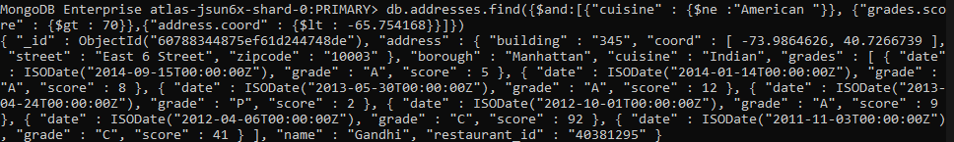

Q12.

MongoDB Enterprise atlas-jsun6x-shard-0:PRIMARY> db.addresses.find({ "cuisine" : {$ne : "American "},"grades.score" :{$gt: 70},"address.coord" : {$lt : -65.754168}} );

{ "_id" : ObjectId("60788344875ef61d244748de"), "address" : { "building" : "345", "coord" : [ -73.9864626, 40.7266739 ], "street" : "East 6 Street", "zipcode" : "10003" }, "borough" : "Manhattan", "cuisine" : "Indian", "grades" : [ { "date" : ISODate("2014-09-15T00:00:00Z"), "grade" : "A", "score" : 5 }, { "date" : ISODate("2014-01-14T00:00:00Z"), "grade" : "A", "score" : 8 }, { "date" : ISODate("2013-05-30T00:00:00Z"), "grade" : "A", "score" : 12 }, { "date" : ISODate("2013-04-24T00:00:00Z"), "grade" : "P", "score" : 2 }, { "date" : ISODate("2012-10-01T00:00:00Z"), "grade" : "A", "score" : 9 }, { "date" : ISODate("2012-04-06T00:00:00Z"), "grade" : "C", "score" : 92 }, { "date" : ISODate("2011-11-03T00:00:00Z"), "grade" : "C", "score" : 41 } ], "name" : "Gandhi", "restaurant_id" : "40381295" }..

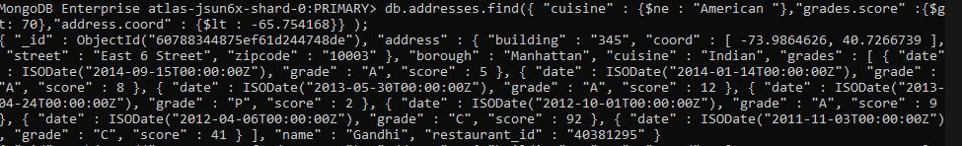

Q13.

MongoDB Enterprise atlas-jsun6x-shard-0:PRIMARY> db.addresses.find( { "cuisine" : {$ne : "American "}, "grades.grade" :"A", "borough": {$ne : "Brooklyn"}} ).sort({"cuisine":-1});

{ "_id" : ObjectId("60788345875ef61d24474deb"), "address" : { "building" : "89", "coord" : [ -73.9995899, 40.7168015 ], "street" : "Baxter Street", "zipcode" : "10013" }, "borough" : "Manhattan", "cuisine" : "Vietnamese/Cambodian/Malaysia", "grades" : [ { "date" : ISODate("2014-08-21T00:00:00Z"), "grade" : "A", "score" : 13 }, { "date" : ISODate("2013-08-31T00:00:00Z"), "grade" : "A", "score" : 13 }, { "date" : ISODate("2013-04-11T00:00:00Z"), "grade" : "C", "score" : 3 }, { "date" : ISODate("2012-10-17T00:00:00Z"), "grade" : "A", "score" : 4 }, { "date" : ISODate("2012-05-15T00:00:00Z"), "grade" : "A", "score" : 10 } ], "name" : "Thai Son", "restaurant_id" : "40559606" }

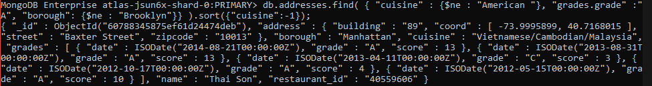

Q14.

MongoDB Enterprise atlas-jsun6x-shard-0:PRIMARY> db.addresses.find({name: /^Wil/},{"restaurant_id" : 1,"name":1,"borough":1,"cuisine" :1});

{ "_id" : ObjectId("60788344875ef61d244746e6"), "borough" : "Brooklyn", "cuisine" : "Delicatessen", "name" : "Wilken'S Fine Food", "restaurant_id" : "40356483" }

{ "_id" : ObjectId("60788344875ef61d244746e9"), "borough" : "Bronx", "cuisine" : "American ", "name" : "Wild Asia", "restaurant_id" : "40357217" }

{ "_id" : ObjectId("60788347875ef61d244754ee"), "borough" : "Bronx", "cuisine" : "Pizza", "name" : "Wilbel Pizza", "restaurant_id" : "40871979" }

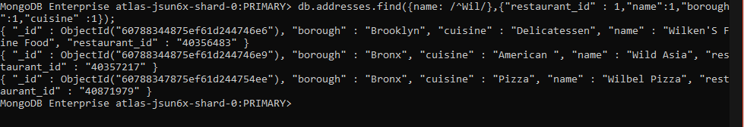

Q15.

MongoDB Enterprise atlas-jsun6x-shard-0:PRIMARY> db.addresses.find({name: /ces$/},{"restaurant_id" : 1,"name":1,"borough":1,"cuisine" :1});

{ "_id" : ObjectId("60788345875ef61d24474b72"), "borough" : "Manhattan", "cuisine" : "American ", "name" : "Pieces", "restaurant_id" : "40399910" }

{ "_id" : ObjectId("60788345875ef61d24474c31"), "borough" : "Queens", "cuisine" : "American ", "name" : "S.M.R Restaurant Services", "restaurant_id" : "40403857" }

{ "_id" : ObjectId("60788345875ef61d24474c37"), "borough" : "Manhattan", "cuisine" : "American ", "name" : "Good Shepherd Services", "restaurant_id" : "40403989" }

{ "_id" : ObjectId("60788346875ef61d244750ea"), "borough" : "Queens", "cuisine" : "Ice Cream, Gelato, Yogurt, Ices", "name" : "The Ice Box-Ralph'S Famous Italian Ices", "restaurant_id" : "40690899" }

{ "_id" : ObjectId("60788347875ef61d244752ec"), "borough" : "Brooklyn", "cuisine" : "Jewish/Kosher", "name" : "Alices", "restaurant_id" : "40782042" }

{ "_id" : ObjectId("60788347875ef61d24475508"), "borough" : "Manhattan", "cuisine" : "American ", "name" : "Re: Sources", "restaurant_id" : "40876068" }

MongoDB Enterprise atlas-jsun6x-shard-0:PRIMARY>

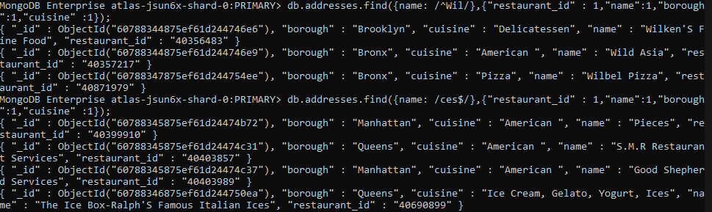

Q16.

MongoDB Enterprise atlas-jsun6x-shard-0:PRIMARY> db.addresses.find({"name": /.*Reg.*/},{"restaurant_id" : 1,"name":1,"borough":1,"cuisine" :1});

{ "_id" : ObjectId("60788344875ef61d244746e7"), "borough" : "Brooklyn", "cuisine" : "American ", "name" : "Regina Caterers", "restaurant_id" : "40356649" }

{ "_id" : ObjectId("60788344875ef61d244747e4"), "borough" : "Manhattan", "cuisine" : "Café/Coffee/Tea", "name" : "Caffe Reggio", "restaurant_id" : "40369418" }

{ "_id" : ObjectId("60788344875ef61d244748f3"), "borough" : "Manhattan", "cuisine" : "American ", "name" : "Regency Hotel", "restaurant_id" : "40382679" }

{ "_id" : ObjectId("60788345875ef61d24474c10"), "borough" : "Manhattan", "cuisine" : "American ", "name" : "Regency Whist Club", "restaurant_id" : "40402377" }

{ "_id" : ObjectId("60788345875ef61d24474cf3"), "borough" : "Queens", "cuisine" : "American ", "name" : "Rego Park Cafe", "restaurant_id" : "40523342" }

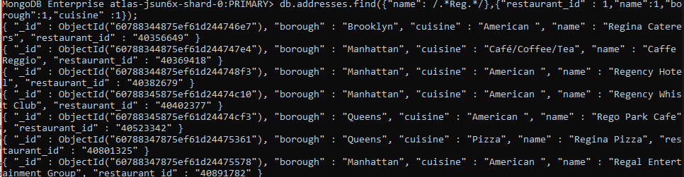

Q17.

MongoDB Enterprise atlas-jsun6x-shard-0:PRIMARY> db.addresses.find({ "borough": "Bronx" , $or : [{ "cuisine" : "American " },{ "cuisine" : "Chinese" }] } );

{ "_id" : ObjectId("60788344875ef61d244746e9"), "address" : { "building" : "2300", "coord" : [ -73.8786113, 40.8502883 ], "street" : "Southern Boulevard", "zipcode" : "10460" }, "borough" : "Bronx", "cuisine" : "American ", "grades" : [ { "date" : ISODate("2014-05-28T00:00:00Z"), "grade" : "A", "score" : 11 }, { "date" : ISODate("2013-06-19T00:00:00Z"), "grade" : "A", "score" : 4 }, { "date" : ISODate("2012-06-15T00:00:00Z"), "grade" : "A", "score" : 3 } ], "name" : "Wild Asia", "restaurant_id" : "40357217" }

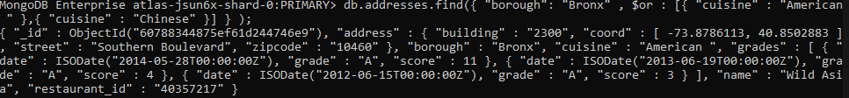

Q18.

MongoDB Enterprise atlas-jsun6x-shard-0:PRIMARY> db.addresses.find({"borough" :{$in :["Staten Island","Queens","Bronx","Brooklyn"]}},{"restaurant_id" : 1,"name":1,"borough":1,"cuisine" :1});

{ "_id" : ObjectId("60788344875ef61d244746df"), "borough" : "Bronx", "cuisine" : "Bakery", "name" : "Morris Park Bake Shop", "restaurant_id" : "30075445" }

{ "_id" : ObjectId("60788344875ef61d244746e0"), "borough" : "Brooklyn", "cuisine" : "Hamburgers", "name" : "Wendy'S", "restaurant_id" : "30112340" }

{ "_id" : ObjectId("60788344875ef61d244746e2"), "borough" : "Brooklyn", "cuisine" : "American ", "name" : "Riviera Caterer", "restaurant_id" : "40356018" }

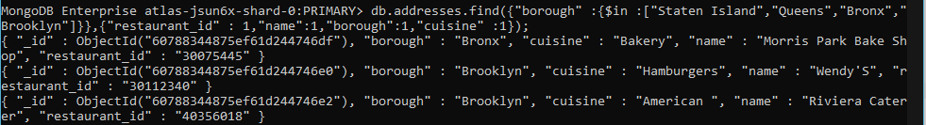

Q19.

MongoDB Enterprise atlas-jsun6x-shard-0:PRIMARY> db.addresses.find({"borough" :{$nin :["Staten Island","Queens","Bronx","Brooklyn"]}},{"restaurant_id" : 1,"name":1,"borough":1,"cuisine" :1});

{ "_id" : ObjectId("60788344875ef61d244746e1"), "borough" : "Manhattan", "cuisine" : "Irish", "name" : "Dj Reynolds Pub And Restaurant", "restaurant_id" : "30191841" }

{ "_id" : ObjectId("60788344875ef61d244746ec"), "borough" : "Manhattan", "cuisine" : "American ", "name" : "1 East 66Th Street Kitchen", "restaurant_id" : "40359480" }

{ "_id" : ObjectId("60788344875ef61d244746f1"), "borough" : "Manhattan", "cuisine" : "American ", "name" : "Glorious Food", "restaurant_id" : "40361521" }

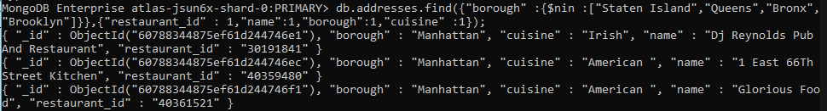

Q20.

MongoDB Enterprise atlas-jsun6x-shard-0:PRIMARY> db.addresses.find({"grades.score" : { $not: {$gt : 10}}},{"restaurant_id" : 1,"name":1,"borough":1,"cuisine" :1});

{ "_id" : ObjectId("60788344875ef61d244746ea"), "borough" : "Brooklyn", "cuisine" : "American ", "name" : "C & C Catering Service", "restaurant_id" : "40357437" }

{ "_id" : ObjectId("60788344875ef61d244746ec"), "borough" : "Manhattan", "cuisine" : "American ", "name" : "1 East 66Th Street Kitchen", "restaurant_id" : "40359480" }

{ "_id" : ObjectId("60788344875ef61d244746f0"), "borough" : "Brooklyn", "cuisine" : "Delicatessen", "name" : "Nordic Delicacies", "restaurant_id" : "40361390" }

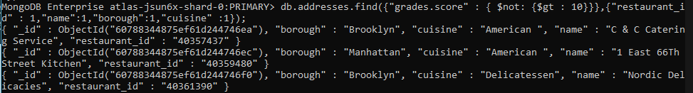

Q21.

MongoDB Enterprise atlas-jsun6x-shard-0:PRIMARY> db.addresses.find({$or: [{name: /^Wil/}, {"$and": [{"cuisine" : {$ne :"American "}}, {"cuisine" : {$ne :"Chinees"}}]}]},{"restaurant_id" : 1,"name":1,"borough":1,"cuisine" :1});

{ "_id" : ObjectId("60788344875ef61d244746df"), "borough" : "Bronx", "cuisine" : "Bakery", "name" : "Morris Park Bake Shop", "restaurant_id" : "30075445" }

{ "_id" : ObjectId("60788344875ef61d244746e0"), "borough" : "Brooklyn", "cuisine" : "Hamburgers", "name" : "Wendy'S", "restaurant_id" : "30112340" }

{ "_id" : ObjectId("60788344875ef61d244746e1"), "borough" : "Manhattan", "cuisine" : "Irish", "name" : "Dj Reynolds Pub And Restaurant", "restaurant_id" : "30191841" }

{ "_id" : ObjectId("60788344875ef61d244746e3"), "borough" : "Queens", "cuisine" : "Jewish/Kosher", "name" : "Tov Kosher Kitchen", "restaurant_id" : "40356068" }



Q22.

MongoDB Enterprise atlas-jsun6x-shard-0:PRIMARY> db.addresses.find( {"grades.date": ISODate("2014-08-11T00:00:00Z"), "grades.grade":"A" , "grades.score" : 11}, {"restaurant_id" : 1,"name":1,"grades":1});

{ "_id" : ObjectId("60788344875ef61d2447475d"), "grades" : [ { "date" : ISODate("2014-08-11T00:00:00Z"), "grade" : "A", "score" : 13 }, { "date" : ISODate("2013-07-22T00:00:00Z"), "grade" : "A", "score" : 9 }, { "date" : ISODate("2013-03-14T00:00:00Z"), "grade" : "A", "score" : 12 }, { "date" : ISODate("2012-07-02T00:00:00Z"), "grade" : "A", "score" : 11 }, { "date" : ISODate("2012-02-02T00:00:00Z"), "grade" : "A", "score" : 10 }, { "date" : ISODate("2011-08-24T00:00:00Z"), "grade" : "A", "score" : 11 } ], "name" : "Neary'S Pub", "restaurant_id" : "40365871" }

{ "_id" : ObjectId("60788344875ef61d24474838"), "grades" : [ { "date" : ISODate("2014-08-11T00:00:00Z"), "grade" : "A", "score" : 11 }, { "date" : ISODate("2013-12-10T00:00:00Z"), "grade" : "A", "score" : 9 }, { "date" : ISODate("2013-06-10T00:00:00Z"), "grade" : "A", "score" : 12 }, { "date" : ISODate("2012-06-08T00:00:00Z"), "grade" : "A", "score" : 13 }, { "date" : ISODate("2012-01-25T00:00:00Z"), "grade" : "A", "score" : 8 }, { "date" : ISODate("2011-09-13T00:00:00Z"), "grade" : "A", "score" : 12 } ], "name" : "Don Filippo Restaurant", "restaurant_id" : "40372417" }

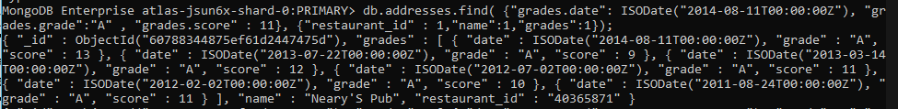

Q23.

MongoDB Enterprise atlas-jsun6x-shard-0:PRIMARY> db.addresses.find( { "grades.1.date": ISODate("2014-08-11T00:00:00Z"), "grades.1.grade":"A" , "grades.1.score" : 9}, {"restaurant_id" : 1,"name":1,"grades":1});

{ "_id" : ObjectId("60788345875ef61d24474d0a"), "grades" : [ { "date" : ISODate("2015-01-12T00:00:00Z"), "grade" : "A", "score" : 10 }, { "date" : ISODate("2014-08-11T00:00:00Z"), "grade" : "A", "score" : 9 }, { "date" : ISODate("2014-01-14T00:00:00Z"), "grade" : "A", "score" : 13 }, { "date" : ISODate("2013-02-07T00:00:00Z"), "grade" : "A", "score" : 10 }, { "date" : ISODate("2012-04-30T00:00:00Z"), "grade" : "A", "score" : 11 } ], "name" : "Club Macanudo (Cigar Bar)", "restaurant_id" : "40526406" }

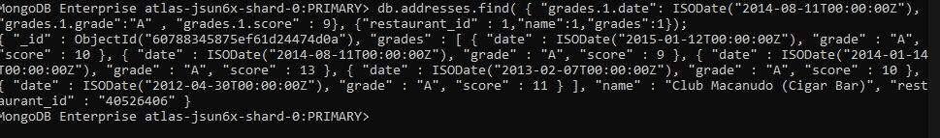

Q24.

MongoDB Enterprise atlas-jsun6x-shard-0:PRIMARY> db.addresses.find( { "address.coord.1": {$gt : 42, $lte : 52}},{"restaurant_id" : 1,"name":1,"address":1,"coord":1});

{ "_id" : ObjectId("60788344875ef61d24474981"), "address" : { "building" : "47", "coord" : [ -78.877224, 42.89546199999999 ], "street" : "Broadway @ Trinity Pl", "zipcode" : "10006" }, "name" : "T.G.I. Friday'S", "restaurant_id" : "40387990" }

{ "_id" : ObjectId("60788344875ef61d244749ad"), "address" : { "building" : "1", "coord" : [ -0.7119979, 51.6514664 ], "street" : "Pennplaza E, Penn Sta", "zipcode" : "10001" }, "name" : "T.G.I. Fridays", "restaurant_id" : "40388936" }

{ "_id" : ObjectId("60788345875ef61d24474c06"), "address" : { "building" : "3000", "coord" : [ -87.86567699999999, 42.61150920000001 ], "street" : "47 Avenue", "zipcode" : "11101" }, "name" : "Di Luvio'S Deli", "restaurant_id" : "40402284" }

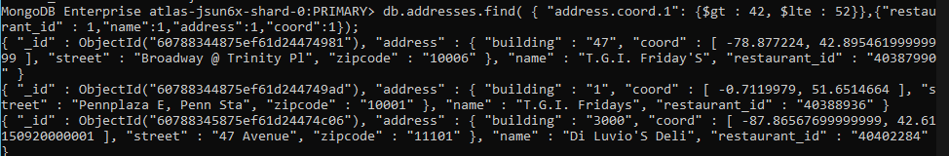

Q25.

db.addresses.find().sort({"name":1});

in asc order

Q26.

db.addresses.find().sort({"name":-1});

in desc order

Q27.

db.addresses.find({"address.street" : { $exists : true } } );

MongoDB Enterprise atlas-jsun6x-shard-0:PRIMARY> db.addresses.find({"address.street" : { $exists : true } } );

{ "_id" : ObjectId("60788344875ef61d244746df"), "address" : { "building" : "1007", "coord" : [ -73.856077, 40.848447 ], "street" : "Morris Park Ave", "zipcode" : "10462" }, "borough" : "Bronx", "cuisine" : "Bakery", "grades" : [ { "date" : ISODate("2014-03-03T00:00:00Z"), "grade" : "A", "score" : 2 }, { "date" : ISODate("2013-09-11T00:00:00Z"), "grade" : "A", "score" : 6 }, { "date" : ISODate("2013-01-24T00:00:00Z"), "grade" : "A", "score" : 10 }, { "date" : ISODate("2011-11-23T00:00:00Z"), "grade" : "A", "score" : 9 }, { "date" : ISODate("2011-03-10T00:00:00Z"), "grade" : "B", "score" : 14 } ], "name" : "Morris Park Bake Shop", "restaurant_id" : "30075445" }

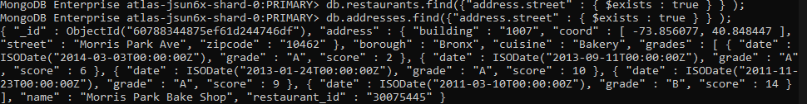

Q28.

db.addresses.find({"address.coord" : {$type : 1}});

Q29.

MongoDB Enterprise atlas-jsun6x-shard-0:PRIMARY> db.addresses.find({"grades.score" :{$mod : [7,0]}},{"restaurant_id" : 1,"name":1,"grades":1});

{ "_id" : ObjectId("60788344875ef61d244746df"), "grades" : [ { "date" : ISODate("2014-03-03T00:00:00Z"), "grade" : "A", "score" : 2 }, { "date" : ISODate("2013-09-11T00:00:00Z"), "grade" : "A", "score" : 6 }, { "date" : ISODate("2013-01-24T00:00:00Z"), "grade" : "A", "score" : 10 }, { "date" : ISODate("2011-11-23T00:00:00Z"), "grade" : "A", "score" : 9 }, { "date" : ISODate("2011-03-10T00:00:00Z"), "grade" : "B", "score" : 14 } ], "name" : "Morris Park Bake Shop", "restaurant_id" : "30075445" }

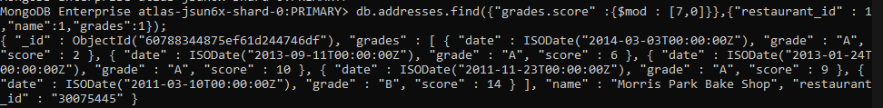

Q30.

MongoDB Enterprise atlas-jsun6x-shard-0:PRIMARY> db.addresses.find({ name : { $regex : "mon.*", $options: "i" } },{"name":1,"borough":1,"address.coord":1,"cuisine" :1});

{ "_id" : ObjectId("60788344875ef61d24474773"), "address" : { "coord" : [ -73.98306099999999, 40.7441419 ] }, "borough" : "Manhattan", "cuisine" : "American ", "name" : "Desmond'S Tavern" }

{ "_id" : ObjectId("60788344875ef61d2447477c"), "address" : { "coord" : [ -73.8221418, 40.7272376 ] }, "borough" : "Queens", "cuisine" : "Jewish/Kosher", "name" : "Shimons Kosher Pizza" }

{ "_id" : ObjectId("60788344875ef61d24474788"), "address" : { "coord" : [ -74.10465599999999, 40.58834 ] }, "borough" : "Staten Island", "cuisine" : "American ", "name" : "Richmond County Country Club" }

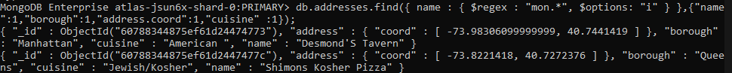

Q31.

MongoDB Enterprise atlas-jsun6x-shard-0:PRIMARY> db.addresses.find({ name : { $regex : /^Mad/i, } },{"name":1,"borough":1,"address.coord":1,"cuisine" :1});

{ "_id" : ObjectId("60788345875ef61d24474c1b"), "address" : { "coord" : [ -73.9860597, 40.7431194 ] }, "borough" : "Manhattan", "cuisine" : "American ", "name" : "Madison Square" }

{ "_id" : ObjectId("60788345875ef61d24474ce9"), "address" : { "coord" : [ -73.98302199999999, 40.742313 ] }, "borough" : "Manhattan", "cuisine" : "Indian", "name" : "Madras Mahal" }

{ "_id" : ObjectId("60788346875ef61d24474f97"), "address" : { "coord" : [ -74.000002, 40.72735 ] }, "borough" : "Manhattan", "cuisine" : "American ", "name" : "Madame X" }

